 | Abdi İpekçi Caddesi Kaşıkçıoğlu Apt. No:42 D:2 34365 Nişantaşı İstanbul  www.artxist.com  info@artxist.com  T. +90 212 291 77 84 F. +90 212 343 69 35 | PRESS RELEASE

“ALLIANCE”

“Alliance”, the 6th solo exhibition of Ansen who is one of the most prominent young artsists of the
contemporary Turkish art, is opening at x-ist on May, 9th. In his works, which have been influential both
domestically and internationally, Ansen transforms mundane daily objects that might otherwise escape
our attention, composing new narratives with ironic commentary by active manipulation
in a digital environment. The artist, who combines the approaches of painting, sculpture and photography, sometimes questions a political or social issue or creates his own story and characters.

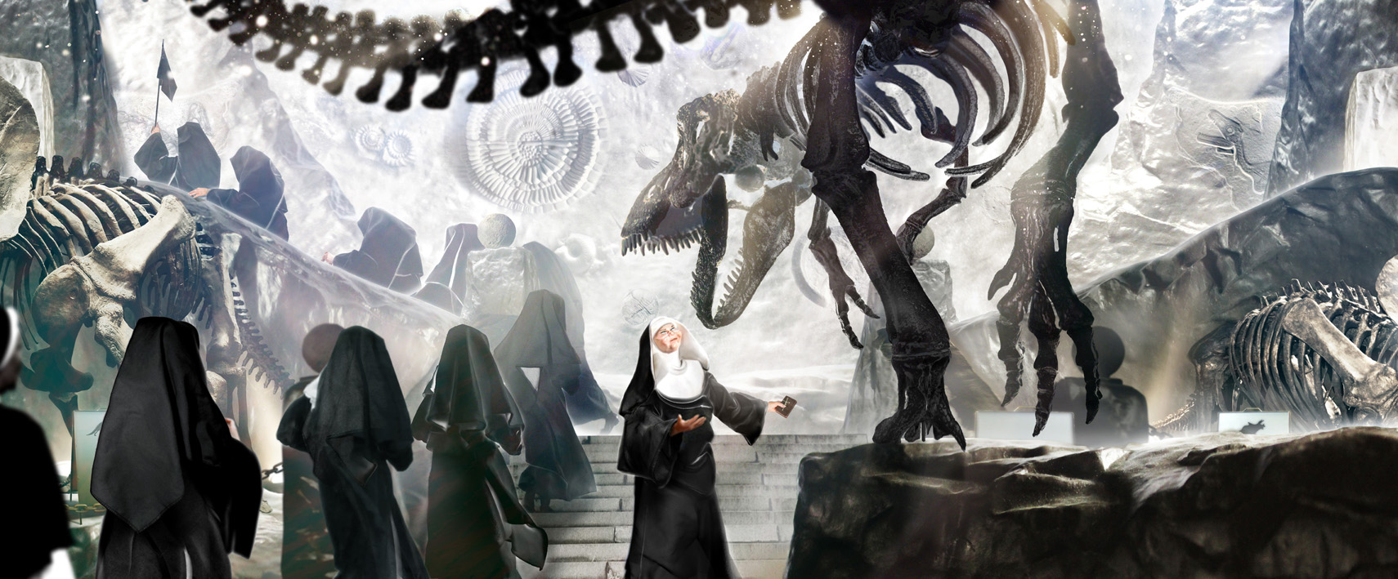

Ansen, “Missing Link”, Digital monoprint, diasec, 101 x 245 cm, 2013

While in his exhibition Ansen addresses the dilemmas, which civil, military, and spiritual communities – who are under the domination of concepts such as power, belonging, allegiance, cause, and sacradness that have left a mark in world history – fall in, by reminding the fact that “the history consists of recurrences”, he uses these historical concepts as a starting point only; originally his stories take form through his imagination. Each one of his works is as memorable as the most critical scene of a movie, as tactfully thought as a stage décor that is prepared meticulously. In the scenes that is written and directed by him, Ansen directs his technique -which he has mastered- in a way that serves fiction. In some of his works, via leaving the marks of his realist expression in the background, the artist makes the audience focus on the figures with real gestures, not the fictive-scene that is built in the foreground or the details. His works, which reinterpret history via imagination, in fact accommodate the cues of his thinking process.

The new solo exhibition of Ansen, whose works have been featured in exhibitions in several countries around the world such as Dubai, China, Taiwan, and Germany, will be on view at x-ist between May 9th and June 15th.

Artist’s Biography

Ansen graduated from the Department of Painting at Mimar Sinan Fine Arts Faculty, and he held five solo exhibitions at x-ist so far which are titled “x-ist-ence” (2004), “Resistance” (2006), “Menace” (2008), “The Trace” (2009), and “Malevolence” (2011). His works were featured in Sotheby’s London 2009, 2010, 2011 & 2012 and Christie’s Dubai 2011 & 2012 Contemporary Turkish Art Auctions. The domestic and international group exhibitions that he has participated since 2005 include “Young Expansions” (Pera Museum, Istanbul, 2005), “Tradition of the New: New Aspects in Contemporary Asian Art” (Sakshi Gallery, Taiwan, 2009), “A Subjective Panorama on Turkish Contemporary Photography” (Maison des Métallos, Paris, 2009), “Confessions of Dangerous Minds” (Saatchi Gallery, London, 2011) and “Samawi Collection II Exhibition” (Ayyam Gallery, Dubai, 2012). Additionally, his works were displayed at Contemporary Istanbul’06, 07, 08, 09, 10 & 11, Art Fair Cologne’06 (Germany, 2006), CIGE’08 – China International Gallery Exposition (Beijing, China), ShContemporary’09 (Shanghai Asia Pacific Contemporary Art Fair), SCOPE New York 2010, ART HK’10 (Hong Kong International Art Fair), SCOPE Basel 2010, Art Dubai 2011 and 2012 fairs. Ansen is featured in the book titled “Unleashed: Contemporary Art From Turkey”, which is first published in 2010.

